ENVS 1200: Assignment 2 – An Alternative Campus Tour: Interrogating the Neoliberal University

Dates of Tour: October 20 and November 3 (you must be present on both days)
Worth: 10% of final grade

Learning outcomes:
    - ability to research and take in the information provided by the Teaching Assistant and course readings on a feature on campus and then convey that research and information orally to one or a couple of fellow students
    - ability to tell stories about different features on the York University Campus that come from different perspectives
    - ability to see and convey orally and in writing an understanding of the contestation or competing views about several campus features
    - ability to bring in course concepts relayed in the lectures and course readings into your role as tour guide, tourist and writer of the campus tour essay. Some of these concepts include environmental sustainability, social justice, civic engagement, the neoliberal and enlightenment university, racism, ageism, sexism, heterosexism, ageism, speciesism, and classism,
    - ability to follow the instructions, meet a deadline, and ask questions of the Teaching Assistant and your fellow students if you are unclear about specific aspects of the assignment

During the campus tours on October 20 and November 3, you will play the role of campus tourist one week and tour guide the other week. As tour guide you will be assigned a station on campus where you will stay for part of the class. In the tutorial on October 13, you will be briefed by your Teaching Assistant about the significance of the station, the different stories that can be told about it, and the questions that can be asked about it. You should also do your own research for the October 13 training session in order to make a contribution to the knowledge of the station. In preparation for the October 13 tutorial you should also read all the readings on the campus listed on Moodle for that date.

On the campus tours on October 20 and November 3, a student tour guide will present and discuss the stories of “his/her” station with a tourist. As a campus tourist you will visit all the five stations in the order indicated in the accompanying Campus Tour Instructions. Begin with your own station and do a practice run as guide and tourist. Then be sure to visit the stations in the order they are listed in the instructions: this is to ensure an even flow of tourists to each station. After you have reached station 5, proceed to station 1. When arriving at each station, take notes and be inquisitive. Also make sure that you get a signature from the Teaching Assistant to verify your visit to each station.

At the conclusion of the campus tour on November 3, you will return to your seminar room and there you will be given specific instructions on how to proceed with writing the campus tour essay. The instructions, signed and numbered by the Teaching Assistant, will be handed out at the conclusion of the Campus Tour on November 3 in exchange for you handing in the Campus Tour Signature Sheet. In order to be valid, the Signature Sheet should contain five signatures. You will thus have to earn the privilege of writing the campus tour report by having participated fully as both a guide and tourist.

Keep in mind the course themes (stated in the learning outcomes above) as you act out your roles as guides and tourists. Also think about how to be reflexive and analytical rather than descriptive in your thinking about the stations you visit.

Dress warmly for the Campus Tour. We will proceed regardless of the type of weather or temperature. If it rains, be sure to bring umbrellas, rubber boots and rain gear. Try not to bring too much to carry but do take along a pen and a clipboard where you can attach the map, the Campus Tour Instructions and Signature Sheet, and blank paper to write notes on. You may also want to bring a light snack.

The Campus tour on October 20 will begin immediately after the lecture. The tour on November 3 will begin at your own station at 2:30 pm promptly. Tour guides and tourists should be at their station a few minutes early.
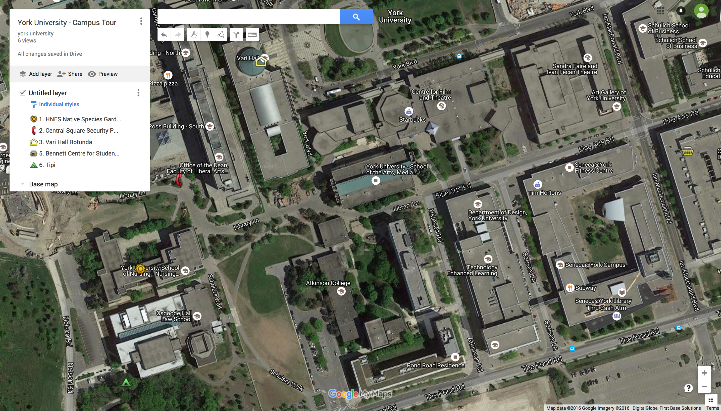
Campus Tour Instructions and Signature Sheet. SAVE AND TURN IN WITH YOUR ESSAY.

Station number | Location of the Stations on the accompanying Campus Map (be sure to visit the stations in numerical order | Where exactly to meet at the station | Signature of the Teaching Assistant at the station | Time
1 | HNES Native Species Garden, Teaching Assistant 1 | Front of the HNES Building
2 | Central Square Security Phone, Teaching Assistant 2 | The south entrance facing the Sticky Wicket, the large orange steel sculpture between Central Square and the HNES Building
3 | Vari Hall, Teaching Assistant 3 | Centre of Rotunda
4 | Bennett Centre for Student Services– Teaching Assistant 4 | Corner of Fine Arts Road and Ian MacDonald Boulevard
5 | The Tipi, Teaching Assistant 5 | Behind Osgoode Hall in the garden of Hart House. Enter the back of the HNES Bldng to reach the HNES Garden
AFTER STATION 5 PROCEED TO STATION 1

Student’s Name: Teaching Assistant:

